
 | Borneo Engineering & Advanced Multidisciplinary International Journal (BEAM)  Volume 6, Issue x, May 2027, Pages x-xx |  | Front Cover
Title of The Article Title of The Article Title of The Article
Muhammad Sufyan Safwan Mohamad Basir¹*, Timotius Petrus Ayi², Faris Hamdani¹

¹Department of Electrical Engineering, Politeknik Mukah, KM 7.5 Jalan Oya, 96400, Mukah, Sarawak, Malaysia
²Department of Commerce, Politeknik Mukah, KM 7.5 Jalan Oya, 96400, Mukah, Sarawak, Malaysia

*Corresponding author: safwan@pmx.edu.my
Please provide an official organisation email of the corresponding author
 |  | Full Paper
Article history
Received
X Month 202Y
Received in revised form
XA Month 202Y
Accepted
XB Month 2027
Published online
XB Month 2027
 |  | 
Abstract

A good abstract should consist of an introduction, problem statement, quantitative results & discussion and quantitative conclusion. Paper can be submitted in English. Abstract should be between 200-250 words. *CRITICAL: Do Not Use Symbols, Special Characters, Footnotes, or Math in Paper Title or Abstract. This electronic document is a “live” template and already defines the components of your paper [title, text, heads, etc.] in its style sheet. This is just an example of the abstract. This paper presents a design of wireless emergency power shut down switch that can be operated remotely through a smartphone, tablet, and PC over the industry’s network connection. The proposed switch is realized by using the Internet of Things (IoT) as a platform to cut off the power supply from a safe distance far away from the hazards while connected to the operational network. From the testing and analysis of the proposed system, the coverage of the system has been greatly improved up to a maximum of 30 meters apart and the percentage of accuracy and reliability to shut down is 92%. The proposed system through the IoT Gecko Platform and the Wi-Fi modules are also able to perform instant commands, where the average delay obtained is less than 1.3 seconds in powering or depowering a load unit and proved to be superior to the already existing wired emergency switches.

Keywords: - Internet of Things, emergency switch, remote access
Copyright © This is an open access article distributed under the terms of the Creative Commons Attribution License |  |  |  | 

1. Introduction
An emergency power shut down switch can simply be defined as a safety button to forcedly turn off the incoming power supply of the facility and units in an emergency when it cannot be shut down in the usual manner. Such an emergency switch, as shown in Fig. 1, can be seen in a wide array of places such as industries, schools, and hospitals. However, the disadvantage of a wired system is that it cannot be controlled in a remote area (Baggini et al., 2007; Nag & Patel, 1998 and Khan & Abbasi, 1999), hence it is worth using wireless control technology as a platform to cut off the power supply which can be operated and utilized from a much safer distance as compared to the pre-existing standard emergency switches.
As far as wireless control technology is concerned, the IoT concept was employed. This refers to the use of the standard network connection of the company to carry out the necessary operations over an IoT platform. The Wi-Fi technology was preferred over other connection types such as NFC and Bluetooth because the distance and range of connectivity offered by other connections has limited due to lower power and bandwidth (Vermaat et al 2017). As the safety of the users is the utmost priority while designing this project, the Wi-Fi technology through the LAN connection proved to be the most feasible option as the communication media between the Wi-Fi control module and the smart devices of the users such as smart phones, tablets, and personal computer.
In this work, the user utilizes a smart device which can connect to the operational network through a smart phone. This device is controlled using IoT based platform that requires the user to key in a password to gain access into the emergency switch of the industry. This is made possible as both the user’s device and the wireless control switch are connected in the same network. The reason for a password is to increase security and authority in the system to mitigate the risk of any misuse. As the user turns off the power supply wirelessly from a smart phone, the wireless module conveys the information to the microcontroller which in turn acts accordingly to the received instructions. This makes it possible to control the power supply of the facility from a remote area and in a much quicker and safer manner (Akbar et al., 2020 and Yaningsih et al., 2018).
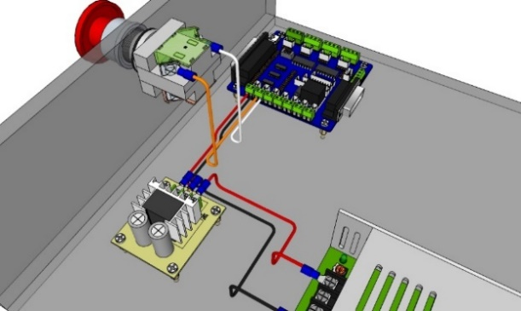

Fig. 1: Standard wired connections (Khan & Abbasi, 1999)

Such emergency switches can be seen in many places such as industries and schools. However, these switches are all installed and connected through wires and poses a serious limitation as shown in Fig. 1 (Khan & Abbasi, 1999 and Shamsudin et al., 2015). To overcome the obstacle raised by the wired connections, this paper aims to design and develop an embedded system of Wireless Power cut-off switch which can be operated and utilized from a much safer distance as compared to the pre-existing standard emergency switches. As far as the wireless control technology is concerned, the IoT concept was employed in this project.
2. Methodology
The architecture of the proposed system is shown in Fig. 2. Two major components will be used, which are hardware and software.
2.1 Hardware Component
The main hardware components required for this paper include ATmega328p microcontroller, ESP8266 Wi-Fi module, fuse, LCD display, voltage regulator IC, cables, jumper wires and relay.

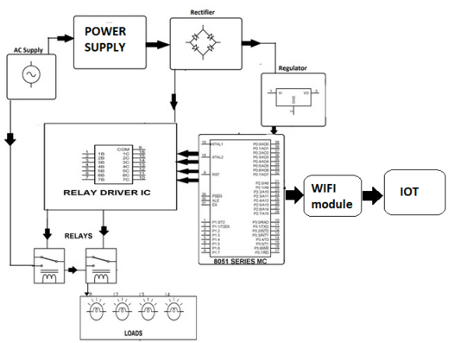

Fig. 2: Block diagram of the proposed system
2.2 Software Component
Meanwhile, for the software components include Arduino IDE to program the ATmega328p microcontroller using C/C++ language. An IoT platform, namely IoT Gecko is employed to carry out power shut down remotely.
The ATmega328p microcontroller is the central processing unit of the emergency IoT based power shut down switch. The function of this microcontroller that has been programmed with the instructions is to analyse the data input obtained from the IoT Gecko platform and to carry out the appropriate procedure by supplying or cutting off the power to the industrial loads. The methodology of this paper is divided into two parts, which are:
a) Industrial-working setup with the aid of DC motors and loads to mimic industrial machines
DC motors are used to mimic the industrial-working setup in the manufacturing industries. This will be done by connecting two or more DC motors into different elements and will further be connected to a central power cut-off switch.
b) Study of connectivity tools such as Bluetooth and wireless fidelity
The study on the most appropriate choice for the network connection is performed. This will include studying the alternatives available including Bluetooth connections and wireless fidelity. The connections are tested under certain criteria such as range and control to determine the best suit for the project. IoT platforms are also tested.
3. Result and Discussion
The preliminary test manifested that the standard AC output of 230 Volts was achieved at all four output terminals that power the industrial loads. After successfully conducting the initial phase of testing, the proposed system was further put into a series of comprehensive tests and analysis that were carried out in individual phases. These tests are crucial to determine the success and viability of the proposed system.
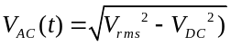 | (1)
A comparison of the data from the range tests are conducted on both the Bluetooth connectivity and the Wi-Fi modules. The Wi-Fi module proves to be superior to the Bluetooth connectivity module in terms of range of successful connectivity for data transfer and control. This is because the Bluetooth connection got disconnected less than 10 meters from the subject device. However, the Wi-Fi connectivity was able to continue data transfer and control the proposed system output at over 30 meters through the IoT platform without any path interruption. This is also supported by the data from the study carried out by Sasani et al., (2019) and Kazeem et al., (2017) as shown in Table 1.
It should also be noted that the Wi-Fi hotspot used to provide the connectivity was from the Android device. This means that the range achieved was far below the potential of Wi-Fi routers. Industries that utilize LAN covering of over 50 meters and wide area networks (WAN) that range in hundreds of meters of network coverage benefit hugely because the IoT platform will be able to control the proposed system from greater distances over 100 meters.

Table 1: Total of vehicles for each entrance

Distance (m) | Signal Strength
 | Bluetooth | ZigBee | Wi-Fi
1 | Very Strong | Very Strong | Very Strong
5 | Strong | Very Strong | Very Strong
7 | Weak | Strong | Very Strong
9 | Unavailable | Strong | Very Strong
11 |  | Strong | Very Strong
30 |  | Weak | Strong
60 |  | Unavailable | Weak
70 |  |  | Weak
100 |  |  | Unavailable

This can further be enhanced by using an IoT web host application that allows the users to connect into the proposed system from remote area if there is internet connectivity. This shows the great potential of the IoT based platform to control the proposed system over the internet regardless of any range limitations.
4. Conclusion
The proposed system of emergency power shut down switch was successfully developed and a total of three tests were carried out in this paper, which are range test, reaction speed/response time test, and system reliability and accuracy test. From the findings of the test, it shows that the range of the Wi-Fi module used in this paper provides the maximum coverage up to 30 meters apart as compared to the other means of connectivity such as Zigbee and Bluetooth. The reaction speed was fast enough with averages ranging delay is less than 1.3 seconds. Meanwhile for the tests related to safety, reliability, and efficiency, the proposed system proving 92% accuracy to shut down the industrial equipments.
Acknowledgement: This research is fully supported by ERGS grant, xxx/TRGS/xxxx. The authors fully acknowledged Ministry of Higher Education (MOHE) and Politeknik Mukah for the approved fund which makes this important research viable and effective.
Author Contributions: The research study was carried out successfully with contributions from all authors.
Conflicts of Interest: The authors declare no conflict of interest.
References
Required amount are at least 20 references. Use the APA Referencing Style 7th edition for the references and the minimum number of references is 10. The pdf file for “A Guide to APA Referencing Style: 7th Edition” can download by using this link.
https://libguides.csudh.edu/ld.php?content_id=52097964

Please use Google Scholar for Bibliography

Using the Simple Text Query form to deposit references: https://doi.crossref.org/simpleTextQuery

Akbar, L. A., Purnomo, D. M. J., Putra, R. A., Hatmojo, R. B. D., Mulyasih, H., & Nugroho, Y. S. (2020). Method development of measuring depth of burn using laser ranging in laboratory scale. Evergreen, 7(2), 268-274.
Baggini, A., Granziero, M., Bua, F., & Cappellari, M. (2007, October). Characterisation of CSS supplied emergency lighting equipment Charachterization of most common emergency lighting sources behaviour in terms of inrush current. In 2007 9th International Conference on Electrical Power Quality and Utilisation (pp. 1-5). IEEE.
Khan, F. I., & Abbasi, S. A. (1999). The world's worst industrial accident of the 1990s what happened and what might have been: A quantitative study. Process Safety Progress, 18(3), 135-145. doi.org/10.1002/prs.680180304.
Ministry of Higher Education Malaysia. (2020). MOHE guide to Entrepreunership Integrated Education (EIE). E-ISBN 978-967-2828-17-4. Retrieved February 2, 2024 from https://cade.upm.edu.my/upload/dokumen/
20221223153043eBookBKA_l_MOHE_Guide_To_Entrepreneurship_Integrated_Education_(EIE)-compressed.pdf.
Vermaat, M. E., Sebok, S. L., Freund, S. M., Campbell, J. T., & Frydenberg, M. (2017). Discovering Computers© 2018: Digital Technology, Data, and Devices. Cengage Learning.
Yaningsih, I., Mahmood, M. H., Wijayanta, A. T., Miyazaki, T., & Koyama, S. (2018). Experimental study on dehumidification technology using honeycomb desiccant block (Doctoral dissertation, Doctoral dissertation, Institute of Carbon-Neutral Energy Research (I2CNER), Kyushu University). Evergreen).

